User Guide

Contents

1. Installation and configuration 2

a. Prerequisites 2

b. Installation 2

c. Configuration 2

2. Application User Interface 3

a. Menu 3

b. Toolbars 4

c. Download Information 4

d. Download Lines 5

e. Log Entries 5

3. Load a new TM 6

4. Use Existing TM 8

5. Start Download 9

6. Stop/Resume a project download 10

Author : Catalin Safta

# Installation and configuration

## Prerequisites

1. Local machine is running Windows 7 or newer
2. .NET Framework 4.0 is installed on the local machine
3. The local machine has enough hard-drive storage for the files to be downloaded
4. Unity Automation API license exists and is installed on OnBase System.

## Installation

Installation package consists of a zip file containg the necessary files required by the application. The following steps must be followe in order to successfully install the OnBase Download Application:

1. If the application was previously installed on the machine, please unistall it first.
2. Unzip the installer file supplied by Matricia Solutions
3. Run setup.exe
4. Agree the License Terms
5. Select the Path where the application will be installed
6. Install and Finish
7. A shortcut will be available on the desktop as well as in the start menu.

## Configuration

The application has a dedicated form for configuration settings. It can be accessed by clicking File - > Options from the application’s main interface. The default settings will be loaded for the application.

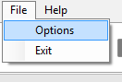 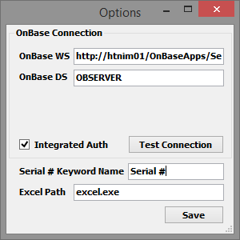

# What is the OnBase Data Downloader

The purpose of the application is to download OnBase documents, using a Traceability Map for determining the files to be downloaded and the folder structure that needs be created.

There are two main operations executed in the downloader application:

1. The extraction of the TM file
2. The download of the documents and creation of the directory structure

## Extraction

The application parses the TM file and extracts the information into a structured form. The information extracted from the TM file are the following:

1. Item
   1. The information found in the column A, starting with A7
   2. Will be used for the folder hierarchy
2. Product #
   1. The information found in the column E, starting with E7
3. Serial #
   1. The information found in the column F, starting with F7
   2. Will be used for naming the folders in the hierarchy
   3. Wil be used for querying records in OnBase
4. ID
   1. The information found in the column G, starting with G7
5. Product
   1. The information found in the column B, starting with B7

After the information has been extracted, the application queries OnBase for information about documents that will be downloaded. The OnBase documents will have the serial number keyword with the value stated in the TM file. When this operation is finished, the log file will be created.

The log file represents the metadata of a download process. It contains the information extracted from the TM lines as well as new information regarding the OnBase documents (document handle, name). Also information regarding the download process for the files is stored in the log (information messages and error messages).

Having the log file means that a previous download process for a specific project can be loaded into the application interface directly from disk, without needing any extra queries and parsing of the TM file.

## Download

The second operation is the actual download of the files and the creation of the directory structure on local disk drive.

In this process, the application identifies the documents that need to be downloaded for each line in the TM, using the log and starts the download procedure. After the file is downloaded, it will be saved on the hard drive in the corresponding folder, as described in the TM file.

Example:

For the following situation :

|  |  |
| --- | --- |
| **ITEM** | **SERIAL** |
| 1.1 | **11223344-01** |
| 1.2 | 11223344-02 |
| **1.1** | 11223344-03 |
| 1.1.1 | **11223344-01** |

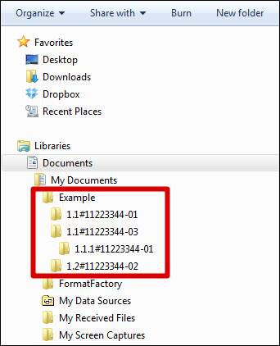

# Application User Interface

## Menu

There are 4 menus:

1. File -> Options
   1. The settings options for the application.
   2. Contains the information needed for connecting to the OnBase Application Service
      1. The WS address (Service.asmx);
      2. OnBase DS (Dataset used for connection);
      3. Username (Only if *Integrated Auth* is unchecked);
      4. Password (Only if *Integrated Auth* is unchecked);
      5. Integrated Auth checkbox (if checked, the application will use current user credentials to authenticate with the OnBase Application Service);
      6. The name of the keyword that contains the serial information for querying OB;
      7. The path to the Excel application (used for opening the log file using Excel).
2. File -> Exit
   1. Closes the application.
   2. If the application is downloading when the Exit button is pressed, a popup message will appear informing the user that there is a process running in the background and that exiting closing the application will prevent that process from finishing the task.
3. Help -> Documentation
   1. Will open this document, containing the user guide for the application.
4. Help -> About
   1. Opens a window informing about the application’s version and software provider.

## Toolbars



There are 4 buttons available in the toolbar:

1. New Download
   1. Will open the context for a new operation.
   2. Two options available:
      1. TM File
      2. Existing download file
   3. If a log file for the same project will be found on the disk, a new dialog will prompt the user for merging the two projects of keep only the new one.
2. Start Download
   1. Will start the download of the files from OnBase for a loaded TM
   2. Is enabled only after a TM file / existing project has been selecteted
3. Stop Download
   1. Will stop a download operation, after the download for the current file is completed
   2. Is enabled only when a download operation is executing
4. Export Log
   1. Will open the log file using Excel.
   2. Information regarding the downloaded files and error / info messages logged for download operation

## Download Information

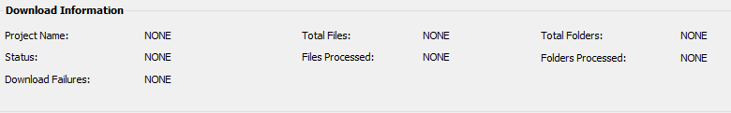

In the Download Information section, general information like the download progress and total folders/files processed will be showed.

1. The Project Name will be loaded after a TM file will be loaded. This represents the value in the A4 cell of the TM;
2. The application Status shows information regarding the state of the application (running or stopped)
3. Download Failures represents the total number of OnBase documents for which the download has been aborted with an error
4. Total Files will represent the total number of OnBase documents found for the serial numbers in the TM file
5. Files Processed is the total number of files for which download had been attempted
6. Total Folders represents the total number of lines in the TM for which a directory will be created (if a file for download is found).
7. Folders Processed is the total number of lines in the TM for which download had been attempted

## Download Lines

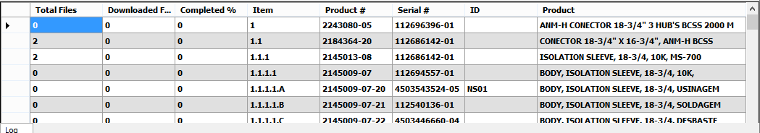

The area where the information extracted after parsing of the TM file will be showed. The columns are:

1. Item
   1. The information found in the column A, starting with A7
   2. Will be used for the folder hierarchy
2. Product #
   1. The information found in the column E, starting with E7
3. Serial #
   1. The information found in the column F, starting with F7
   2. Will be used for naming the folders in the hierarchy
   3. Wil be used for querying records in OnBase
4. ID
   1. The information found in the column G, starting with G7
5. Product
   1. The information found in the column B, starting with B7
6. Total Files
   1. The total files found in OnBase for a serial number
7. Downloaded Files
   1. The number of downloaded documents for a serial number
8. Completed #
   1. The ratio between the downloaded files / total files

## Log Entries

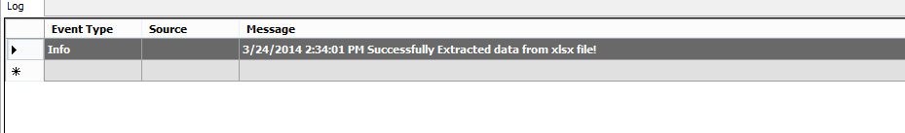

As the application progresses, the information will be recorded in the log section as well as in the log file. The information logged can separate the different stages of the application or can print the progress of the documents download.

# Load a new TM

Choosing to load a new TM offers the posibility of selecting a TM file containing the information needed for downloading. Two options are available on the load of a new TM, depending on previous operations:

1. Import a new TM that has no files downloaded for

This represents a clean start, no history for the TM file. A new folder for the Project will be created and a log file will be saved.

1. Append files to an existing TM and keeping the old files

There is a previous download for the TM and maybe some files have been downloaded that you do not want to download once again. But at the same time, the information in the TM file has changed: a few more lines were added.

The solution is simple: choose to load a new TM file, select the target directory to be the same as the previous downloaded files and when the parsing is complete and the application detects that a log file exists for the same project, it will pop the dialog to choose whether to keep only the new TM or to merge with the old.

How to:

* 1. Press New Download 
  2. Select TM File 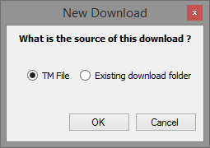
  3. Select the TM file

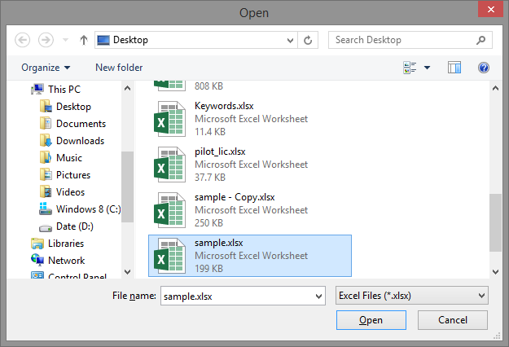

* 1. Select the download directory:

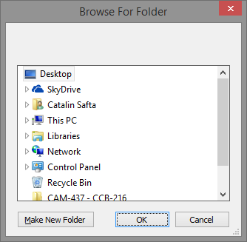

* 1. If a log file is found for the current project, will be prompted to use existing log (merge) / discard

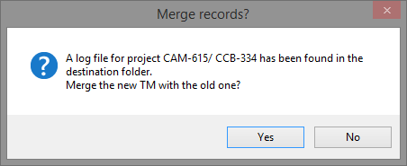

If you choose yes, the new TM file will be merged with the old one. Else the old will be deleted and all the containing files and folders.

# Use Existing TM

Another scenario implies that an existing project must be loaded from the disk. In this case follow the steps below:

* 1. Press New Download 
  2. Select Existing download folder

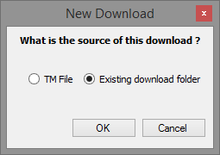

* 1. Choose the folder containg for the project:

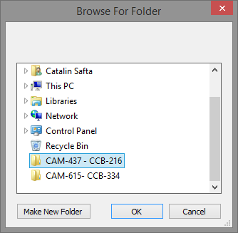

* 1. The message with the status of the loading of the TM will be printed in the Log Entry section:



# Start Download

After the TM file has been loaded, the Start Download button will be enabled. Pressing it will prompt for download method:

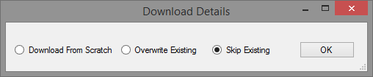

1. Download From Scratch will cause the target folder to be deleted and recreated, all the files contained will be deleted.
2. Overwrite Existing will cause the files found in OnBase to overwrite the existing files, only if they are the same (same document handle and name)
3. Skip Existing will skip the files that already exist on disk and only files that haven’t been downloaded previously to be downloaded.

# Stop/Resume a project download

If during the download, the user wants to interrupt the current process, can do so by pressing the Stop Download button. This will cause the application to stop the download after the current file is downloaded.

Be advised: Pressing the Stop Download button may not result in an instantaneous feedback from the application. If the file which is downloading is a big file and the download will take a long time, the user must wait for that download to complete before the application is closed.

If a download process has been interrupted by pressing the Stop Download button, the download can be resumed by 2 ways:

1. The application was closed after Stop Download was pressed

If the application was close, the context must be recreated. The user must select New Project -> Select Existing Project and choose the project that you want to resume download for.

After it has been loaded in the download lines section, press the Start Download button and select Skip Existing. This will cause the application to jump quickly to the line where it was interrupted and continue to download files until it is either stopped or finishes.

1. The application was not closed after Stop Download was pressed

If the application was not closed and another TM was not loaded, the user must only press the Start Download button and the Skip Existing option and the application will jump quickly to the line where it was interrupted and continue to download files until it is either stopped or finishes.